**Waste to Wow: Home Waste Management Recommendation System - Recycling and Upcycling**

Sonali Arcot, Vidushi Bhati, Siddharth Solanki, and Krishna Sameera Surapaneni

Department of Applied Data Science, San Jose State University

DATA 298B: MSDA Project 11

Dr. Ming Hwa Wang

April 30, 2024

**Data Analytics and Intelligent Systems**

**System Requirements Analysis**

***System Boundaries, Actors and Use Cases***

The household waste management system is meticulously designed to efficiently categorize waste into distinct groups, including organic, recyclable, hazardous, and homegoods, with the aim of fostering proper disposal practices. Beginning with comprehensive data preprocessing from various sources, the system advances through model development stages for waste classification and object detection. These sophisticated models seamlessly integrate with a recommendation system, furnishing tailored suggestions for waste disposal methods. Complementing this functionality is a user-friendly interface facilitating real-time waste classification and recommendation generation, ensuring accessibility across diverse user bases. Furthermore, the system's integration with external resources such as waste disposal facilities and recycling centers significantly bolsters its effectiveness in promoting sustainable waste management practices, thereby addressing critical environmental concerns. Across a spectrum of institutional settings spanning hospitals, universities, libraries, and office buildings, the waste management system extends its utility to users seeking to effectively manage household waste. Through collaborative efforts, these stakeholders optimize waste management practices and champion environmental sustainability initiatives tailored to the unique requirements of diverse settings, thereby fostering a culture of responsible waste management across institutional landscapes.

***High-level Data Analytics and Machine Learning Functions and Capabilities***

The project employs sophisticated data analytics and machine learning (ML) techniques to develop an intelligent garbage classification and waste management system aimed at addressing the prevalent issue of improper household waste disposal. Utilizing diverse image datasets sourced from platforms such as Mandaly and TrashNet, alongside meticulous preprocessing including data annotation and augmentation, the system undertakes precise identification and categorization of various household waste items into distinct groups including organic, recyclable, hazardous, and homegoods.

Leveraging advanced ML models such as Xception, InceptionResNet, ResNet-50, MobileNetv2, and YOLOv8, the system ensures accurate classification of garbage materials. Data analytics for the project is structured across four key phases: elicitation, analysis, specification, and validation & verification. During the elicitation phase, ML functions are trained specifically on garbage-related characteristics, ensuring focused processing and training for accurate garbage classification. Subsequently, the analysis stage is driven by performance metrics encompassing accuracy, misclassification rates, and predicted probabilities to evaluate the efficacy of the system. Requirements specification dictates uniformity in data collection and processing, necessitating consistent formats, sizes, and resolutions for training data collected from various sources.. Continuous validation of requirements ensures alignment between training data and real-world scenarios, while runtime data analysis facilitates system performance monitoring, necessitating regular retraining of ML systems to adapt to evolving datasets.

Upon classification of garbage materials into distinct categories, the system furnishes tailored recommendations for disposal methods, recycling, upcycling, or donation, thus promoting environmentally conscious waste management practices at the household level. Key deliverables include a suite of garbage classification models, an intuitive real-time garbage classification user interface, and seamless integration with external resources such as the Google Maps API. Technical evaluation metrics encompass garbage classification accuracy, including top-1 accuracy and F1 score, alongside the efficacy of the recommendation system. User feedback mechanisms and comparative evaluations ensure the quality and effectiveness of the system, aiming to mitigate improper waste disposal, reduce environmental impact, and foster sustainable waste management practices within households.

**System Design**

The proposed system architecture, the frontend and backend components work seamlessly to provide efficient waste management solutions for households. In a typical scenario, a user interacts with the system through a user interface connected to a camera-equipped device, such as a smartphone or tablet. The captured image of household waste is then transmitted to the backend system, where it undergoes classification through YOLOv8. These algorithms precisely identify the waste item's category, such as hazardous, biodegradable, recyclable, etc. Additionally, a Language Model (LLM) is integrated to provide recommendations to dispose, recycle, upcycle etc. based on the waste classification. Once processed, the system delivers the recommendations and classifications back to the user interface, displaying them alongside the waste image. Connectivity features are leveraged to integrate with external resources, such as the Google Maps API, for accessing safe disposal locations. Figure 1 shows the overall system design for the project.

**Figure** **1**

*Basic System Design*

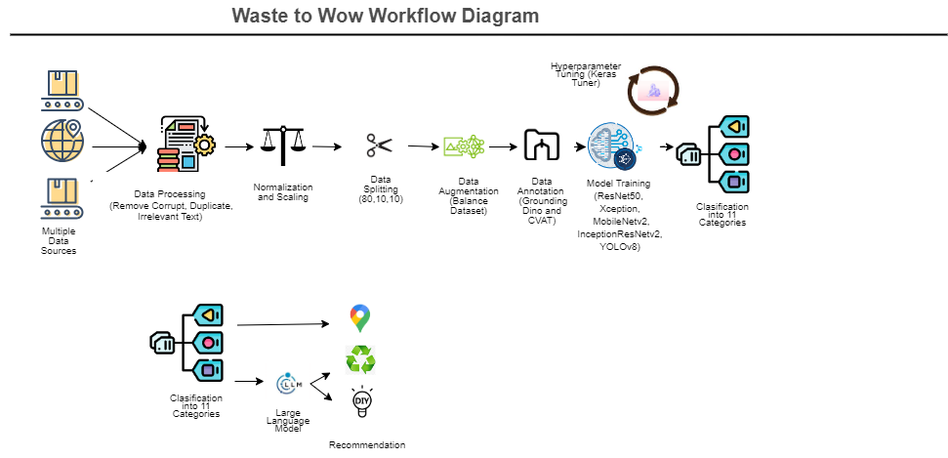

***System Supporting Platforms and Cloud Environment***

The intelligent garbage classification and waste management system rely on OneDrive and Google Drive as primary platforms for data storage and management, ensuring accessibility, collaboration, and data integrity.

**Data Storage and Management.** OneDrive and Google Drive serve as central repositories for storing diverse image datasets sourced from platforms like Mendeley and TrashNet. These platforms offer secure and scalable storage solutions, enabling efficient organization and management of the datasets. With features such as version control and file sharing, OneDrive and Google Drive facilitate collaboration among team members involved in data preprocessing, annotation, and model development.

**Machine Learning Frameworks.** The system leverages popular machine learning frameworks like TensorFlow or PyTorch for developing and deploying sophisticated ML models such as Xception, InceptionResNet, ResNet-50, MobileNetv2, and YOLOv8. These frameworks can be installed and run locally on development machines, utilizing the datasets stored on OneDrive or Google Drive for model training and inference.

**Model Training and Inference.** For model training and inference, local computing resources are utilized, including CPU and GPU resources available on development machines. The datasets stored on OneDrive or Google Drive are accessed directly by the machine learning frameworks, enabling seamless integration with the training and inference processes. Tools like Google Colab may also be utilized for prototyping and experimenting with ML algorithms in a collaborative and interactive environment.

**Integration with External Resources.** While not relying on cloud-based platforms, the system can still integrate with external resources such as the Google Maps API for enhanced functionality. The Google Maps API provides geolocation services, enabling the system to recommend nearby disposal facilities, recycling centers, or donation centers based on the user's location. This integration enhances the system's utility and promotes environmentally conscious waste management practices.

Overall, the system's architecture leverages local storage solutions like OneDrive and Google Drive, combined with local computing resources and machine learning frameworks, to provide scalable, reliable, and efficient solutions for garbage classification and waste management. Figure 2 shows the systems and environment involved in this project.

***Data Management and Data Repository Design***

The project's data management strategy revolves around the collection, organization, preprocessing, and utilization of datasets sourced from various platforms such as TrashNet, Mandalay, and Kaggle. Upon collection, these datasets, comprising images categorized into 11 waste categories, are systematically organized using a standardized naming scheme and folder hierarchy for ease of retrieval and analysis. These folders are stored in a shared Google Drive, ensuring accessibility and efficient storage management. To facilitate model training and validation, the data is further preprocessed and divided into train, validation, and test sets.

**Figure 2**

*Supporting Systems and Environment*

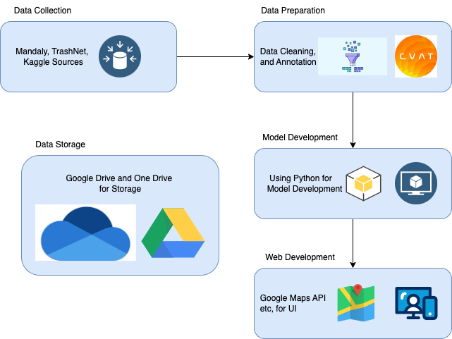

The train and validation sets undergo annotation using tools like CVAT and Grounding Dino, with annotated images stored in designated folders. Utilizing Google Colab as the execution platform, the code is then run to train and validate models using the annotated images. The test set is subsequently employed to estimate model accuracy. Once waste categorization is achieved, with waste categorized as hazardous, biodegradable, disposable, or recyclable, recommendations are generated on proper disposal methods. These recommendations are tailored based on user preferences, offering guidance on hazardous waste disposal, composting, recycling, or safe disposal locations. Overall, this data management and repository design ensure systematic organization, efficient utilization, and user-centric waste management solutions. Figure 3 shows the storage repository design.

**Figure 3**

*Data Repository Design*

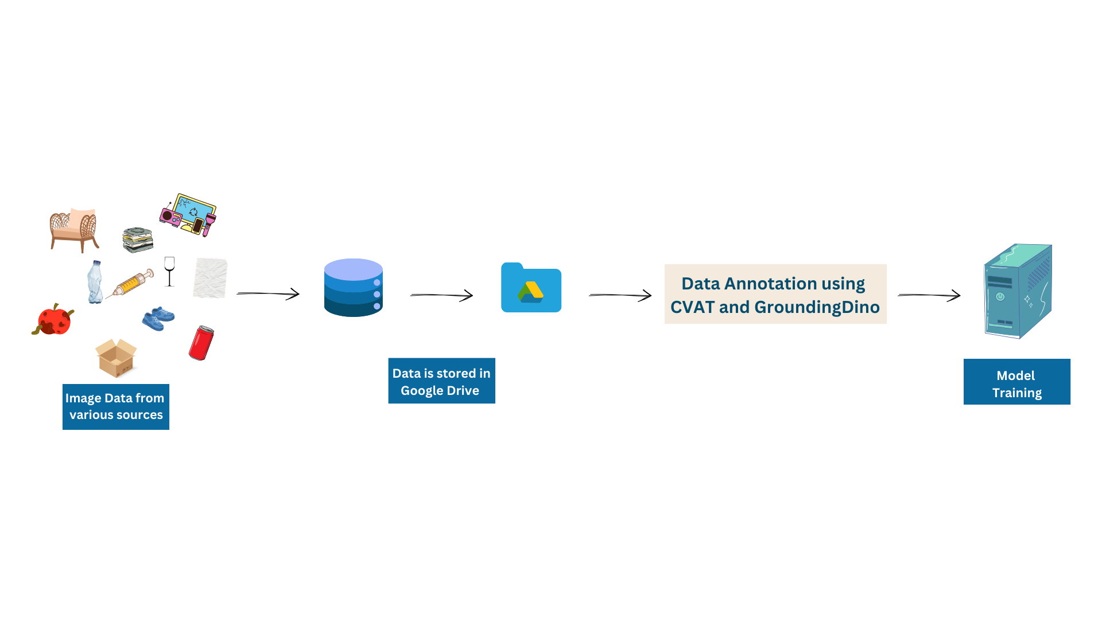

***System User Interface Design***

In the system architecture, the user interacts with the application through a camera interface, utilizing image detection capabilities to identify waste items in real-time. Upon capturing an image, the backend processes the data using the pre-trained YOLOv8 model, loaded from the saved .pt file. This model efficiently categorizes the waste item into its respective category based on the trained classification parameters.

If the detected waste item is classified as hazardous, the system immediately provides the user with information regarding nearby safe disposal locations. Leveraging location-based services and the Google Maps API, the system identifies and presents a list of designated hazardous waste disposal facilities or centers, ensuring proper and safe disposal of the hazardous item.

On the other hand, if the waste item is determined to be non-hazardous, the user is presented with options to decide the fate of the item: reuse, recycle, or dispose. For items deemed suitable for reuse or recycling, the system offers tailored recommendations based on the waste type. For instance, glass items may be recommended for reuse in DIY crafts, while cardboard items may be suggested for recycling at local recycling facilities. These recommendations are provided to the user based on the specific characteristics of the waste item and potential reuse or recycling opportunities.

In cases where disposal is the preferred option, the system once again utilizes the Google Maps API to recommend locations for safe disposal or donation of the waste item. Users are presented with a list of nearby disposal facilities, recycling centers, or donation centers where they can responsibly dispose of the waste item. Overall, the system's integrated approach seamlessly combines image detection, waste categorization, recommendation generation, and location-based services to empower users with actionable insights for effective waste management.

**Intelligent Solution**

***AI and Machine Learning Development***

The project's main objective centers on waste classification and providing recommendations for the disposal, recycling, upcycling, and safe disposal of household waste products. To achieve this, five models were developed, each tailored for specific tasks within the waste classification process. These models include Xception, InceptionResNet, ResNet-50, MobileNetV3, and YOLOv8. Throughout the development journey, image datasets sourced from platforms like TrashNet, Mandalay, and Kaggle served as the cornerstone. These datasets were meticulously organized and preprocessed, with tools like CVAT and Grounding Dino facilitating annotation tasks. TensorFlow and Keras provided the backbone for model training and implementation, while Google Colab served as the execution platform, leveraging its cloud-based infrastructure for seamless code execution.

In addressing the challenges of image processing across various contexts, a spectrum of machine learning solutions has been meticulously developed and applied. MobileNetV2 stands out for its optimization in mobile settings, where computational efficiency is paramount. Leveraging depthwise separable convolutions, MobileNetV2 strikes a delicate balance between performance and computational load, rendering it indispensable for resource-constrained devices. Conversely, Xception emerges as a versatile solution, adept at tackling a broad range of image classification tasks. Its deep architecture and employment of depthwise separable convolutions ensure precision in pattern recognition, though at the expense of substantial computational resources. InceptionResNetV2, blending Inception modules with residual blocks, excels in discerning intricate visual patterns, albeit demanding significant computational prowess. Meanwhile, ResNet-50, renowned for its role in combating the vanishing gradient problem, offers a compelling solution for general image classification with its moderate computational demands.

For tasks spanning object detection, classification, segmentation, and pose tracking, YOLOv8 Medium and YOLOv8 Small present notable options within the landscape of deep learning models. YOLOv8 Medium prioritizes accuracy, leveraging the Darknet architecture for robust performance across various applications. Conversely, YOLOv8 Small prioritizes speed and computational efficiency, making it a preferred choice for real-time applications where swift inference is critical.

In the pursuit of comprehensive image processing solutions, integrated approaches harness the strengths of multiple models. Combining models like Xception for detailed pattern recognition and MobileNetV2 for computational efficiency, integrated solutions strike a harmonious balance between accuracy and resource utilization. Similarly, ensembled models amalgamate predictions from diverse models such as InceptionResNetV2, ResNet-50, and YOLOv8 Medium to bolster overall performance and robustness, particularly in tasks like object detection and classification.

On a broader scale, the project is designed to revolutionize household waste management by integrating cutting-edge technologies. At its core, a Language Model (LLM) is employed to provide tailored recommendations for waste disposal, recycling, and upcycling based on the classification of waste items. This sophisticated model analyzes the characteristics of each waste item and generates personalized guidance for users, promoting sustainable practices and minimizing environmental impact. Additionally, the project harnesses the power of the Google Maps API to further assist users in waste disposal. By integrating with the API, the system recommends safe and convenient locations for waste disposal, taking into account factors such as proximity and user preferences. Whether users seek recycling facilities, donation centers, or hazardous waste disposal sites, the Google Maps API ensures accurate and up-to-date information for informed decision-making.

***Required Input Datasets, Expected Outputs***

The project begins by acquiring image datasets from various sources, including TrashNet, Mandalay, and Kaggle, comprising 11 distinct waste categories: paper, plastic, medical, metal, e-waste, biowaste, furniture, clothes, shoes, glass, and cardboard. To ensure data integrity and quality, preprocessing steps are implemented, such as removing duplicate images and irrelevant data. Subsequently, the dataset is divided into three subsets: train, validation, and test sets, facilitating effective model training and evaluation. For annotation purposes, advanced tools like Grounding Dino are utilized to annotate the majority of the dataset, while e-waste images undergo manual annotation using tools like CVAT. These annotated images serve as crucial inputs for training the machine learning models. The models, including Xception, InceptionResNet, ResNet-50, MobileNetv3, and YOLOv8, are trained on the annotated datasets to accurately classify waste items into their respective categories. Following the training phase, the models are rigorously tested on the designated test set to assess their performance and ensure accurate predictions. Once the prediction process is complete, the waste items are categorized into four main categories: hazardous, recyclable, disposable, and reusable. This categorization is essential for determining appropriate disposal methods and promoting sustainable waste management practices.

To further enhance user experience and provide personalized recommendations, the Language Model (LLM) is integrated into the system. Leveraging the LLM's natural language processing capabilities, the system generates tailored recommendations based on user preferences. Users are presented with options to dispose of the waste, recycle it, or reuse it, based on the categorized waste type and their specified preferences. Additionally, the Google Maps Places API is utilized to retrieve nearby locations for waste disposal based on the user's current location. By integrating location-based services, the system provides users with convenient access to disposal facilities, recycling centers, or donation centers, further facilitating responsible waste management practices.

**System Supporting Environment**

For the development of this project, a diverse array of Python libraries, tools, cloud platforms, and external resources were meticulously employed. These components collectively contributed to the creation of an intelligent garbage classification and waste management system aimed at addressing the pervasive issue of improper household waste disposal. Among these resources were platforms such as Mandaly and TrashNet, which provided access to diverse image datasets crucial for training and validating the system's machine learning models. Additionally, the integration of the Google Maps API enriched the system with location-based services, enabling personalized recommendations for waste disposal methods based on users' geographic locations. Furthermore, the utilization of Grounding Dino streamlined the data annotation process, facilitating the creation of a well-annotated training dataset essential for training accurate garbage classification models.

***Python Libraries***

Python plays a pivotal role in driving the development of the intelligent garbage classification and waste management system, serving as the primary programming language for implementing various machine learning algorithms and data processing tasks.

**TensorFlow and Keras.** TensorFlow and Keras stand as pivotal libraries for the development and training of sophisticated machine learning models within the project. With TensorFlow serving as the backbone for constructing computational graphs and executing machine learning operations efficiently across CPUs and GPUs, Keras provides a high-level API for building and training neural networks with ease. These libraries empower the implementation of state-of-the-art architectures such as Xception, InceptionResNet, ResNet-50, MobileNetv2, and YOLOv8, ensuring the system's capability in accurate garbage classification.

**Pandas and NumPy.** Pandas and NumPy serve as indispensable tools for managing and manipulating data efficiently. Pandas provides data structures and functions to work with structured data, facilitating tasks such as data loading, cleaning, and transformation. NumPy, on the other hand, offers support for numerical operations and multidimensional array manipulation, which are fundamental for processing image data within the system. Together, these libraries streamline the handling of diverse image datasets and annotations, ensuring smooth data flow throughout the garbage classification pipeline.

**Scikit-learn.** Scikit-learn is instrumental in evaluating the performance of the machine learning models deployed in the system. With a wide range of metrics and utilities for classification tasks, including accuracy, misclassification rates, and F1 score, Scikit-learn enables thorough analysis of model efficacy. Its intuitive API allows for seamless integration into the system's validation and verification phases, providing valuable insights into the classification accuracy and overall performance of the garbage classification models.

***Integrated Development Environment (IDE)***

Effective utilization of integrated development environments (IDEs) such as PyCharm and Jupyter Notebooks significantly accelerates the development process by providing comprehensive tools and features tailored for Python development and machine learning models.

**PyCharm.** PyCharm offers a robust integrated development environment tailored for Python development, particularly beneficial for ML projects. Its rich feature set, including code navigation, syntax highlighting, and refactoring tools, enhances developer productivity during the implementation and debugging of machine learning algorithms. PyCharm's seamless integration with version control systems like Git ensures efficient collaboration among team members, fostering a smooth development process for the garbage classification system.

**Google Colab.** Google Colab provides an interactive environment for prototyping and experimentation, well-suited for exploring data and iterating on ML models. The notebook interface allows developers to mix code, visualizations, and explanatory text, facilitating a narrative-driven approach to data analysis and model development. With its ability to run code in a modular and incremental manner, Colab promotes rapid iteration and exploration, making them invaluable for the early stages of developing the garbage classification system.

***Cloud Storage Platforms***

Leveraging cloud storage platforms like Google Drive and OneDrive ensures seamless collaboration and accessibility of project resources across distributed teams. These platforms serve as centralized repositories for storing and sharing datasets, model checkpoints, and documentation, promoting efficient collaboration and accessibility of project assets.

**Google Drive.** Google Drive serves as a centralized repository for storing and sharing project resources, including datasets, model checkpoints, and documentation. Its seamless integration with Google's suite of productivity tools enhances collaboration among team members, allowing for efficient data sharing and version management. Additionally, Google Drive's accessibility from various devices ensures that project assets are readily available to team members, regardless of their location or device.

**OneDrive.** OneDrive complements Google Drive by providing additional storage and backup options, enhancing data redundancy and accessibility within the project. Its synchronization features ensure that project files are securely backed up and accessible across multiple devices, safeguarding against data loss or corruption. With its seamless integration with Microsoft Office applications, OneDrive offers a familiar environment for managing project assets, further enhancing productivity and collaboration among team members

***External Resources and APIs***

Integration of external resources and APIs enhances the system's functionality and user experience. Leveraging APIs such as Google Maps API, along with platforms like Mandaly and TrashNet, enriches the system with valuable data sources and services, contributing to accurate garbage classification and tailored waste management recommendations.

**Mendeley, TrashNet and Kaggle.** Mandaly and TrashNet serve as valuable platforms for sourcing diverse image datasets, enriching the training data for garbage classification models. By accessing these repositories, the system can leverage a wide variety of garbage-related images, ensuring robustness across different waste disposal scenarios. Mandaly and TrashNet contribute to the creation of a well-annotated training dataset, essential for training accurate and reliable garbage classification models within the system.

**Grounding Dino.** Grounding Dino streamlines the data annotation process by providing tools and workflows for labeling images with garbage categories. By leveraging Grounding Dino's annotation capabilities, the system can efficiently generate high-quality annotations for the training dataset, enhancing the performance of the garbage classification models. This platform accelerates the data annotation workflow, enabling the system to process large volumes of image data effectively and expedite the development of the garbage classification system.

**Google Maps API.** The Google Maps API enriches the garbage classification system with location-based services, enabling tailored recommendations for waste disposal methods based on the user's geographic location. By leveraging Google Maps' comprehensive database of locations, the system can identify nearby waste disposal facilities, recycling centers, and donation centers, providing users with convenient and environmentally conscious options for waste management. Integrating this API enhances the system's utility and promotes sustainable waste management practices at the household level.

**System Evaluation and Visualization**

**Analysis of Model Execution and Evaluation Results**

In this project report, a range of metrics is employed to thoroughly assess the performance of classification and object detection models. For classification models, the confusion matrix is utilized to visually depict the alignment between predicted and actual classes, allowing for a comprehensive analysis of accuracy and errors. From this matrix, crucial metrics such as accuracy, precision, recall, and F1 score are derived, providing deep insights into the overall performance of the model and its ability to accurately classify instances.

For object detection models, reliance is placed on the mean Average Precision at 50 (mAP50) metric, which evaluates the precision of predicted bounding boxes against a specified threshold. For instance, the ResNet50 classification model demonstrates an F1-score of 0.91 and an accuracy of 91%, indicative of robust performance with a balanced trade-off between precision and recall. Similarly, the YOLOv8-l object detection model showcases an impressive mAP50 of 0.863 and mAP50-95 of 0.862, underscoring accuracy across diverse thresholds and classes. These meticulously calculated metrics offer a comprehensive evaluation of the models and serve as valuable benchmarks for future improvements and optimizations in the project.

**Achievements and Constraints**

In the project aimed at improving waste management practices, significant strides have been made in addressing the core challenges. By incorporating real-life photos and enhancing infrastructure and computational resources, notable improvements in the model's performance are anticipated. This expansion of the dataset to include objects in diverse environments is expected to enhance the model's ability to accurately classify and identify various types of waste, ensuring effectiveness in real-world scenarios where subtle visual differences in garbage items may occur.

Additionally, the plan to integrate a web application represents a crucial step towards broader adoption and utilization of the solution. This application, designed with a user-friendly interface, will empower individuals to actively participate in waste management efforts using their mobile devices. Furthermore, there is an aim to include a feature that links household-generated waste to relevant businesses selling corresponding items. This innovative connection not only fosters sustainability but also provides businesses with a platform to target products based on user consumption patterns, thereby promoting environmentally conscious purchasing habits. Such forward-thinking strategies have the potential to transform traditional waste management practices, creating a more adaptable system that effectively meets evolving consumer needs while promoting sustainability.

One limitation the project faces is in the high-level categorization of waste items, necessitated by the constraints of available resources. While the project encompasses a diverse range of waste categories, the classification system had to prioritize broader categorization to function effectively within existing resource limitations.

Moving forward, there is a clear aspiration to enhance the project's capabilities by accessing additional resources. This future scope entails refining the categorization process to a more granular level. By doing so, the recommendations generated can become more tailored and appropriate for each specific waste item, thereby significantly improving the overall efficacy and relevance of the project's recommendations.

**System Quality Evaluation of Model Functions and Performance**

The team has established a range of evaluation metrics to assess the correctness of the model, ensuring a comprehensive understanding of its performance across various dimensions. Real-time correctness is gauged by the model's ability to accurately detect the class to which a waste item belongs. With waste items categorized into 11 classes, the model must proficiently classify each item before transmitting the classification to the LLM for recommendation.

System performance is evaluated based on the efficiency of model training with the available resources. Initially, training the models posed a significant challenge due to the large volume of image data. However, this obstacle was overcome by scaling up resources, and reducing the training time from an entire day to just a couple of hours.

System response time is measured from the moment a user presents a waste item to the camera of the device or uploads an image into the system. While this duration may vary depending on the device's internet speed, it typically ranges between 3 to 5 seconds. Following classification, the recommendation system delivers a prompt response within 2 to 3 seconds.

**System Visualization**

Figure 4, displays the confusion matrix for the YoloV8 model, offering insight into the model's proficiency in accurately classifying waste items into their respective categories for recommendation.

**Figure 4**

*YoloV8 Confusion Matrix*

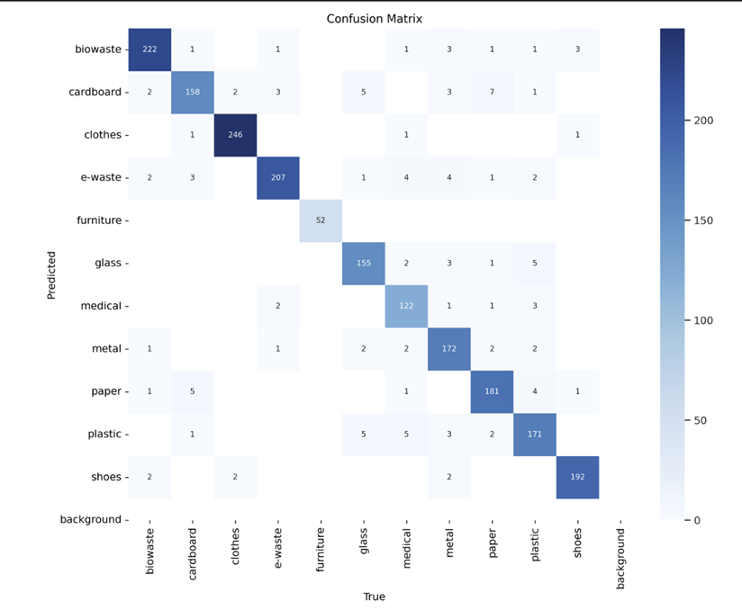

Figure 5 demonstrates the classification performed by the YoloV8 model on a multitude of images supplied to it. It showcases successful categorization of various waste items, paving the way for pertinent recommendations by the LLM for recycling or upcycling

**Figure 5**

*Detection Performance of YoloV8*

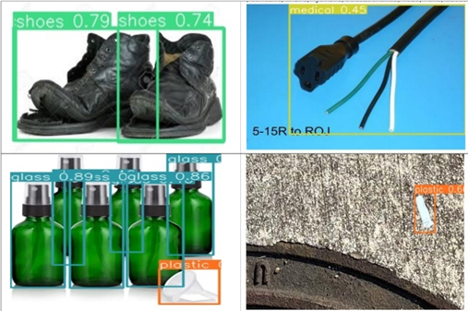

**Conclusion**

**Summary**

The project aimed to reduce improper disposal of waste at household level has made significant strides in addressing core challenges through a multifaceted approach. The development of an easy to use system for waste upcycling and recycling, aims to make households more environmentally conscious by making better waste disposal decisions. By incorporating real-life photos and enhancing infrastructure and computational resources, the project anticipates notable improvements in the model's performance. This includes the expansion of the dataset to include objects in diverse environments, enhancing the model's ability to accurately classify various types of waste. These enhancements are crucial for ensuring effectiveness in real-world scenarios where subtle visual differences in garbage items may occur. Additionally, the integration of a web application represents a pivotal step towards broader adoption and utilization of the solution. The user-friendly interface empowers individuals to actively participate in waste management efforts using their mobile devices.

Overall, the project's achievements hold implications for the field of waste management by showcasing innovative approaches to classification and recommendation systems. The ability to adapt to diverse environments and provide tailored recommendations has the potential to transform traditional waste management practices, creating a more adaptable and sustainable system that meets evolving consumer needs.

**Benefits and Shortcoming**

The project offers notable benefits, including improved accuracy through the integration of real-life photos and expansion of the dataset to diverse environments. This enhances waste classification, fostering more effective waste management practices. Additionally, the user-friendly web application interface encourages community engagement and participation in sustainable efforts. Moreover, linking the system with AI gives the user more options and ideas about how to properly dispose of their waste or utilize it to make decorative or useful things by the way of DIY. The incorporation of the Google Maps API enhances user experience by providing access to local disposal facilities for items like medical or hazardous waste. This feature not only simplifies waste disposal for users but also contributes to the safety of both individuals and municipal workers.

However, limitations exist, such as high-level waste categorization due to resource constraints, potentially leading to less precise recommendations. Resource limitations also initially posed challenges in model training, though addressed by scaling up resources. Furthermore, variability in system response time, influenced by device internet speed, may impact user experiences and real-time decision-making.

**Potential System and Model Applications**

Beyond its primary function as a household tool, the Waste Management System can also serve as a starting point to develop a bigger automated waste segregation system for municipal organizations. Additionally, it can be utilized as an educational tool in schools and community centers to raise awareness about waste management practices. By demonstrating the importance of proper waste segregation and disposal, the system fosters environmentally conscious behaviors among students and community members. Furthermore, businesses can integrate the system into their sustainability initiatives, using it to track and manage waste generated within their premises. This can help identify areas for improvement in waste reduction and recycling efforts, leading to cost savings and environmental benefits**.**

**Experience and Lessons Learned**

The project involved a comprehensive journey through various stages of data processing, from collecting data from multiple sources to merging, cleaning, and transforming it. Data cleaning, although relatively straightforward due to the requirement of removing images with only text, was a crucial step to ensure the quality of the dataset. Augmenting the data likely helped in improving model performance by diversifying the training set. However, the most significant challenge was encountered during data annotation.

Choosing the right annotation tool is critical for efficient and accurate labeling. While CVAT was effective for manual annotation, grounding dino proved useful for automating the annotation process. However, it's essential to recognize limitations, such as the inability to recognize certain categories like e-waste.Despite advancements in automation, certain categories may still require manual annotation. In this case, e-waste images had to be manually annotated due to recognition issues. This highlights the importance of flexibility in the annotation process and being prepared for manual intervention when necessary.

The size of the dataset directly impacts the computational resources required for training models. In this project, the dataset was large, necessitating high-memory GPUs for efficient model training. Future projects should consider the scalability of the dataset and allocate appropriate resources accordingly.Proper resource allocation, including hardware and software, is crucial for the success of the project. Investing in high-memory GPUs upfront can save time and resources in the long run by facilitating smoother model training processes.

While a large dataset is beneficial, ensuring the quality of the data is paramount. Prioritizing data quality over quantity can lead to more accurate models and ultimately better results. This includes thorough data cleaning, meticulous annotation, and validation procedures. Throughout the project, continuous evaluation and refinement of the data and models are essential. This includes regularly assessing the performance of annotation tools, data augmentation techniques, and model training strategies to identify areas for improvement and optimization.

Overall, this project provided valuable insights into the challenges and best practices associated with managing large-scale data processing tasks, particularly in the context of computer vision projects. By carefully navigating through these challenges and applying lessons learned, future projects can be executed more efficiently and effectively.

**Recommendations for Future Work**

***Real-life Photo Integration***

For future projects, consider actively collecting and incorporating more real-life photos of waste items into the dataset. This can be done by crowdsourcing or collaborating with local waste management organizations to gather diverse images representing different types of household waste. Additionally, implementing data augmentation techniques specific to real-life scenarios, such as varying lighting conditions and backgrounds, can further enhance the dataset's robustness and improve model performance.

***Infrastructure Enhancement***

To address the need for improved infrastructure and processing resources, future projects should explore cloud-based solutions and distributed computing frameworks. Utilizing platforms like AWS, Google Cloud, or Microsoft Azure can provide access to scalable resources for training and inference tasks, enabling more efficient model development and deployment. Additionally, investing in GPU acceleration and parallel processing techniques can further optimize model performance and reduce training time.

***Environmental Variation***

To enable better model generalization and accurate waste classification across varied environments, future projects should focus on diversifying the dataset to include images captured in different settings, such as urban, suburban, and rural areas. This can involve collaborating with stakeholders in various regions to collect data representative of local waste disposal practices and environmental conditions. Additionally, incorporating techniques like domain adaptation and transfer learning can help the model adapt to new environments and improve classification accuracy.

***Continuous Data Enrichment***

Given the dynamic nature of waste composition and disposal practices, future projects should prioritize continuous data enrichment efforts. This involves regularly updating the dataset with new waste items, classification labels, and relevant metadata to ensure the model remains up-to-date and adaptable to evolving waste management needs. Collaborating with local waste management authorities, recycling facilities, and environmental organizations can provide valuable insights and access to real-time data sources for ongoing dataset expansion.

***Localization and Multilingual Support***

Recognizing the global nature of waste management challenges, future projects should prioritize localization and multilingual support to cater to diverse communities and regions. This involves translating user interfaces, instructional materials, and recommendation systems into multiple languages to ensure accessibility and usability for non-English speaking populations. Collaborating with local language experts, community leaders, and cultural organizations can help tailor the system to specific linguistic and cultural contexts, enhancing its relevance and adoption worldwide.

**Contributions and Impacts on Society**

The project's focus on enhancing waste management through advanced computer vision and machine learning technologies offers significant contributions to cultural, economic, educational, and social well-being across diverse and multicultural contexts. By promoting sustainable practices and raising awareness about proper waste disposal and recycling, the project fosters a cultural shift towards environmental stewardship and responsibility, transcending cultural boundaries and promoting a shared commitment to the planet. Economically, the project leads to cost reductions in waste management by minimizing landfill congestion and redirecting resources towards other essential services, contributing to economic growth and efficiency at local and national levels. Through accessible educational resources and community engagement initiatives, the project empowers individuals with the knowledge and skills needed to make informed decisions about waste management, fostering a culture of lifelong learning and environmental literacy. Furthermore, the project strengthens social cohesion and resilience by engaging diverse stakeholders in collaborative partnerships and promoting collective action towards common environmental goals. Globally, the project's scalability and replicability enable its impact to extend beyond borders, inspiring similar initiatives and catalyzing a global movement towards sustainable waste management and environmental conservation. The project contributes to building a more resilient and sustainable future for all.